**A/B Testing in Python DataCamp**

1. **Overview of A/B TestingA screenshot of a test

   AI-generated content may be incorrect.**

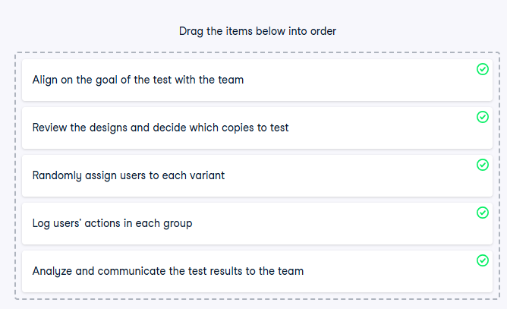

**Randomization effects**

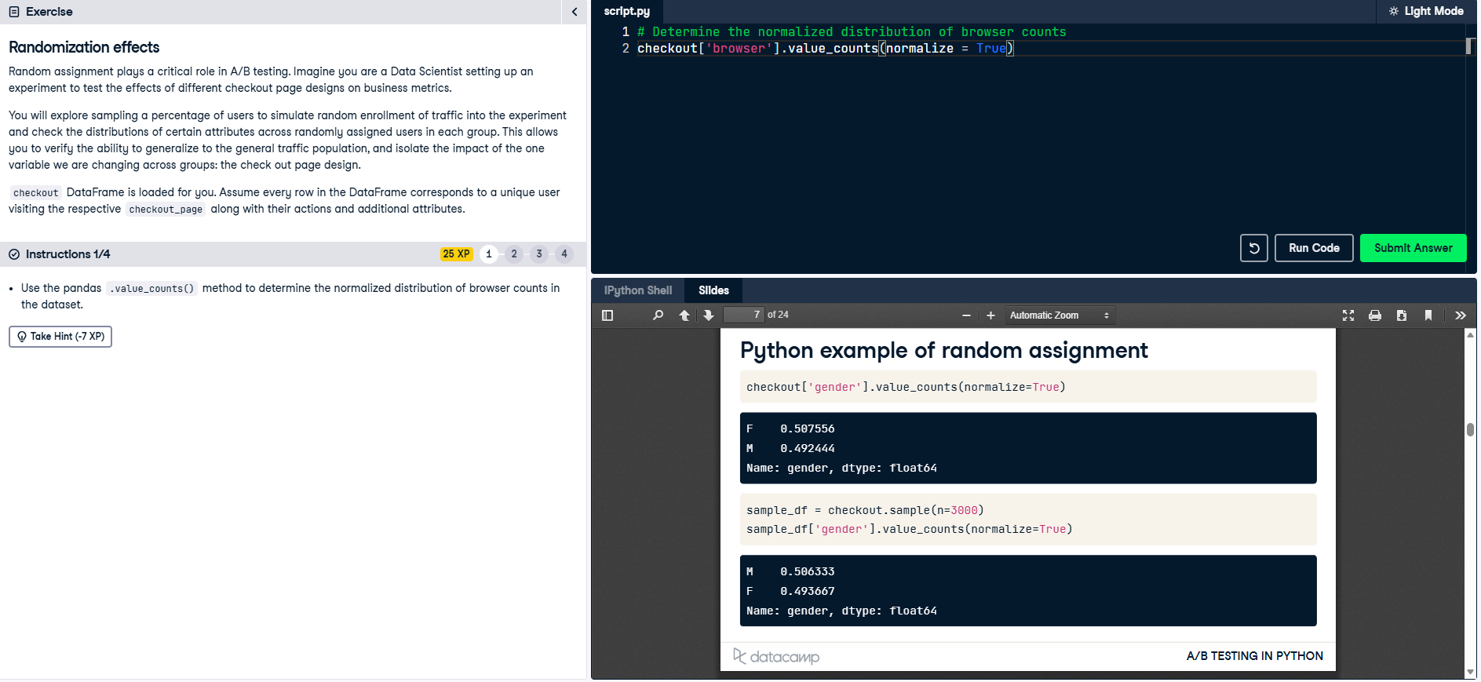

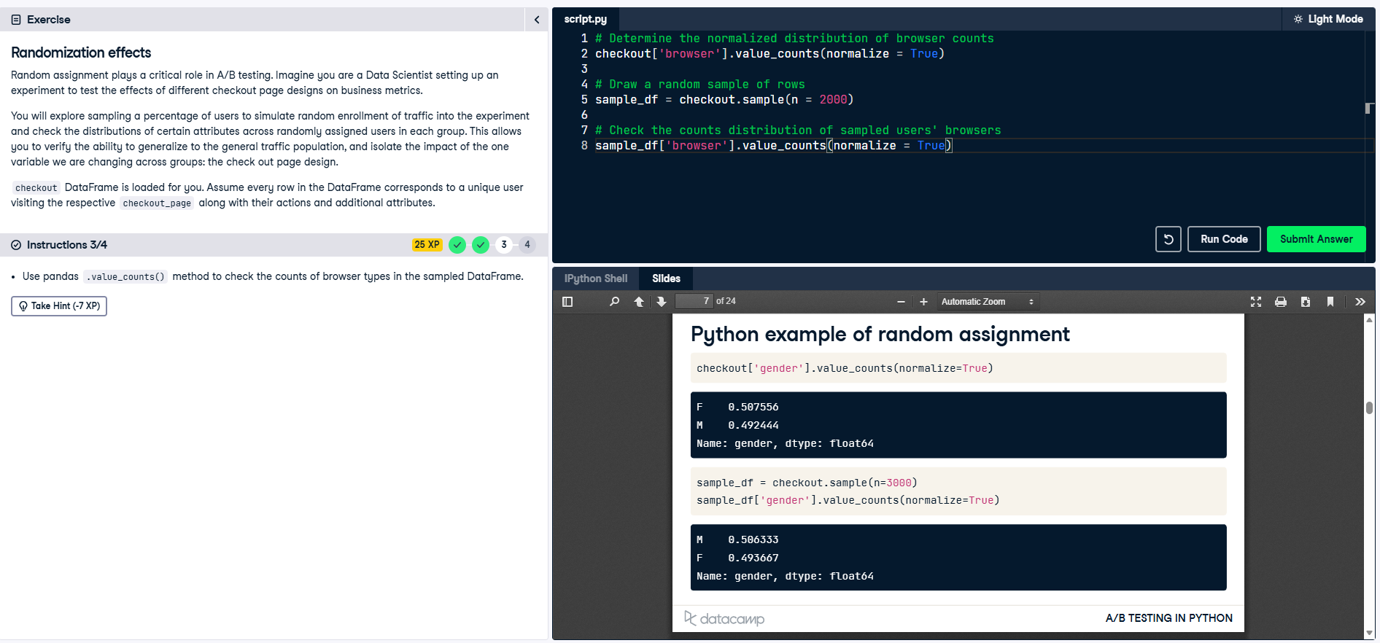

**Correlation visualization**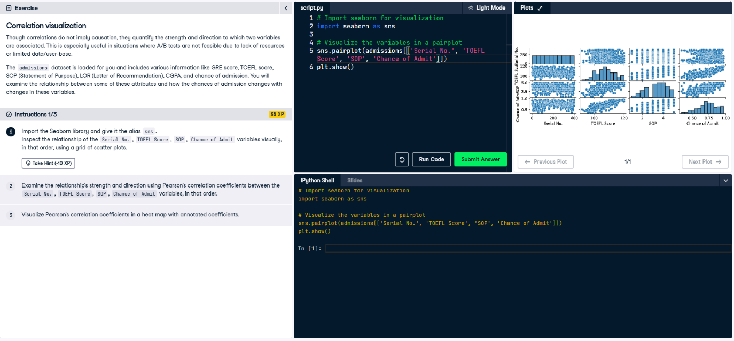

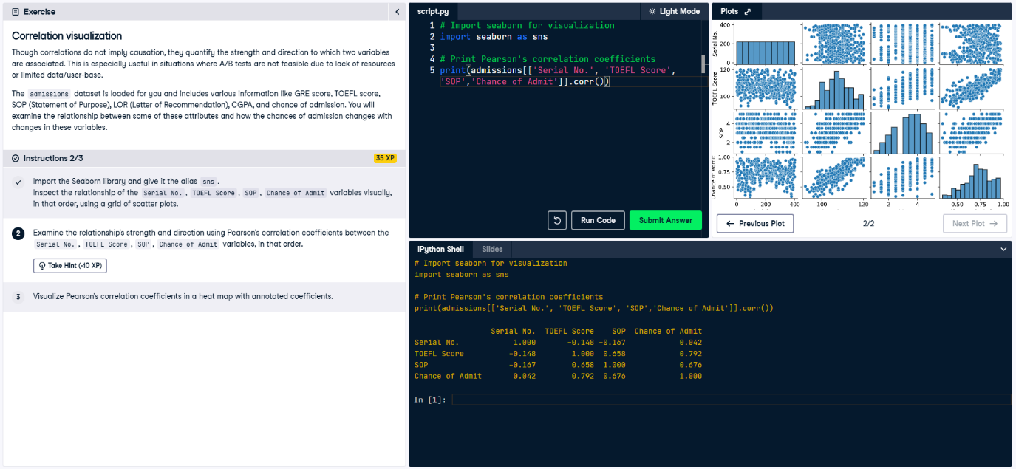

**Correlation or causation?**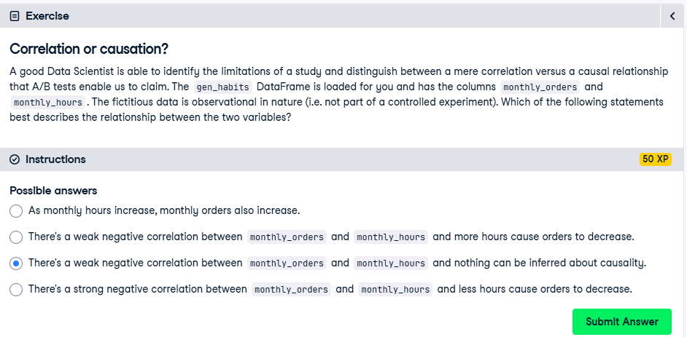

**Means and proportions** 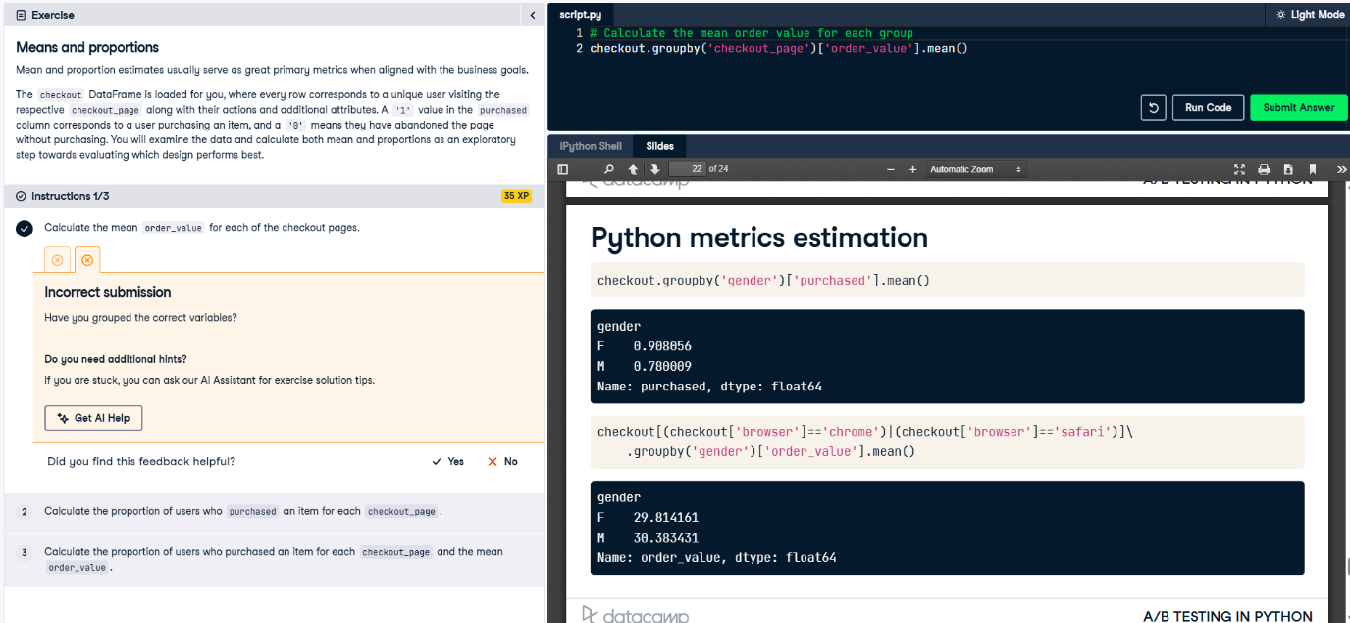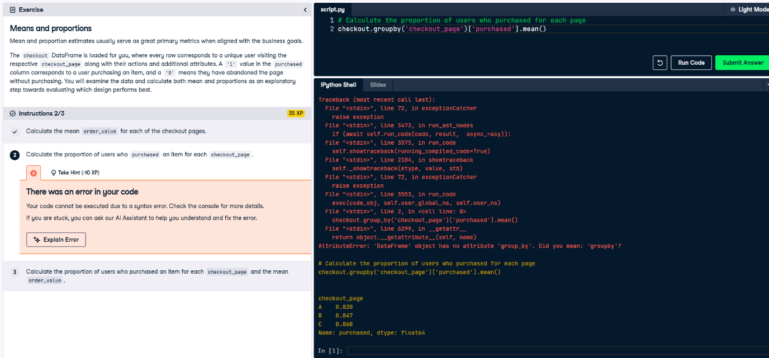

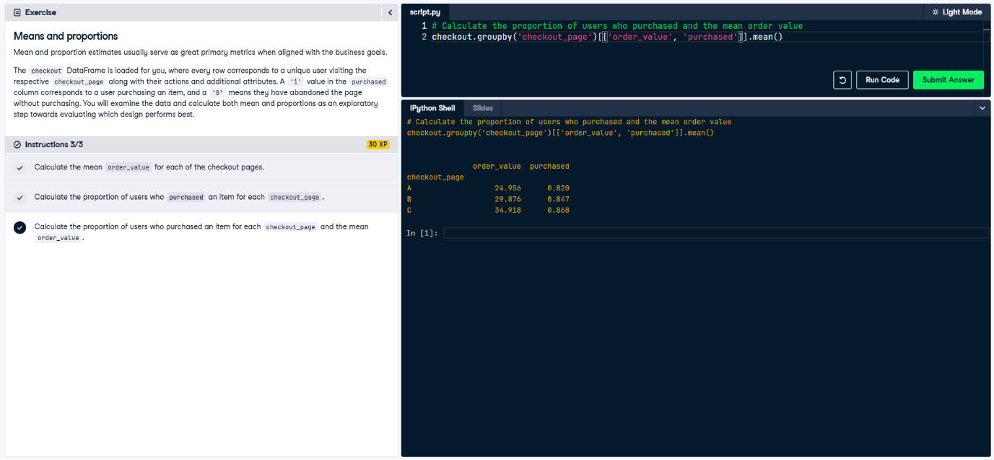

**Ad impressions metrics**

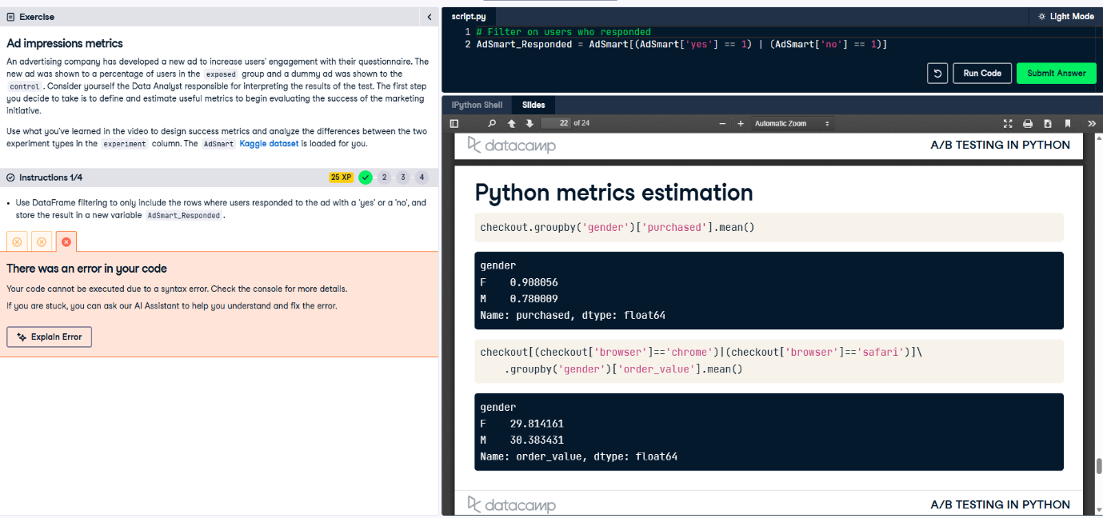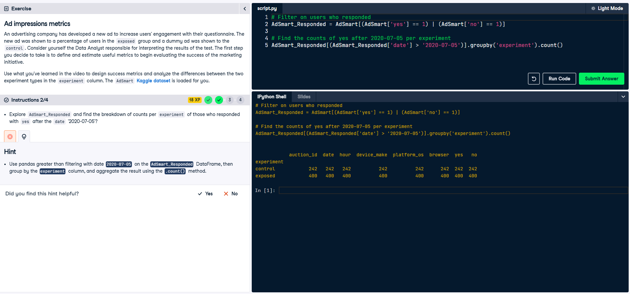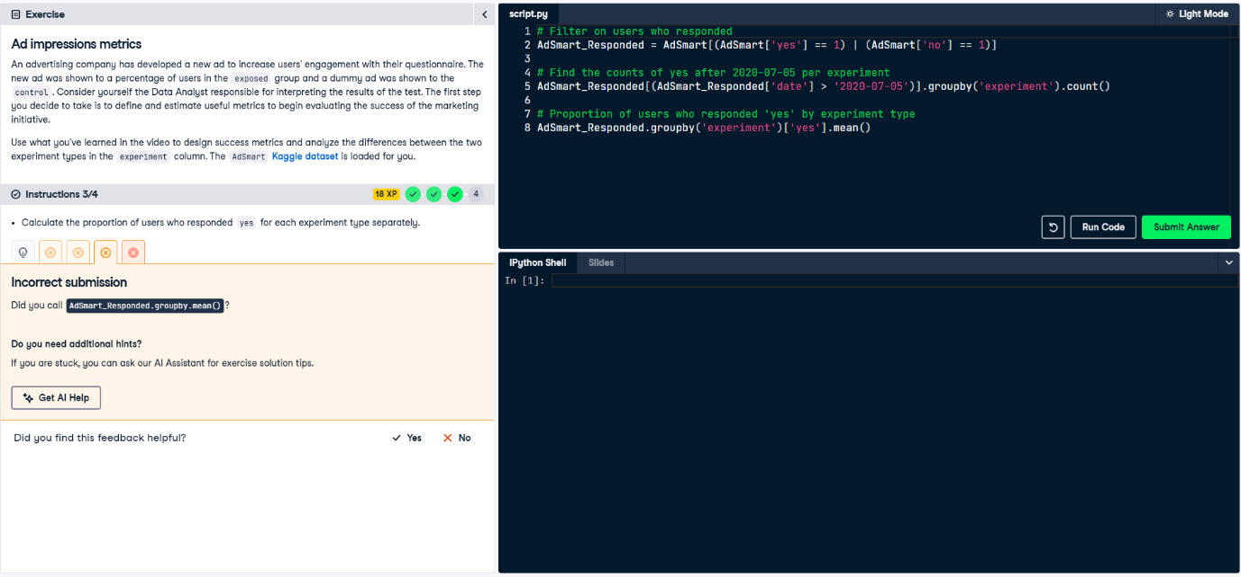

1. **Overview of A/B Testing**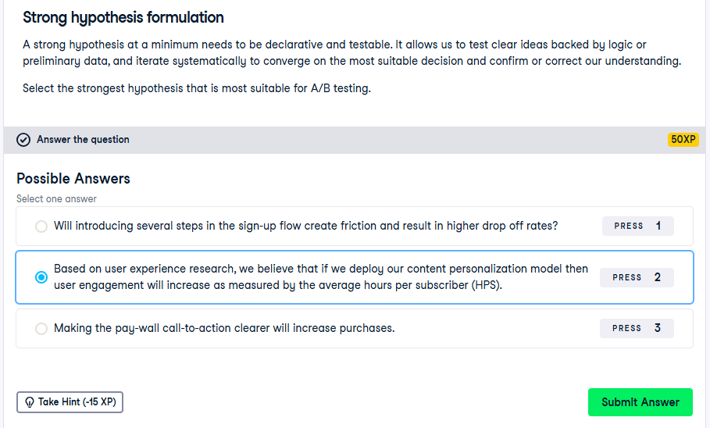

**Plotting distributions**

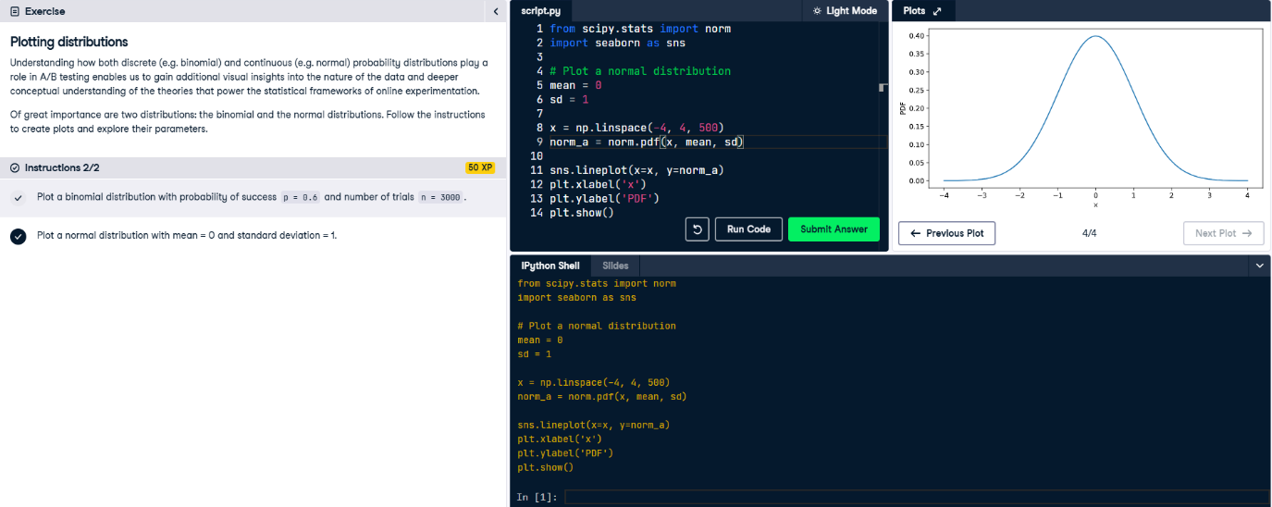

**Central Limit theorem for means**

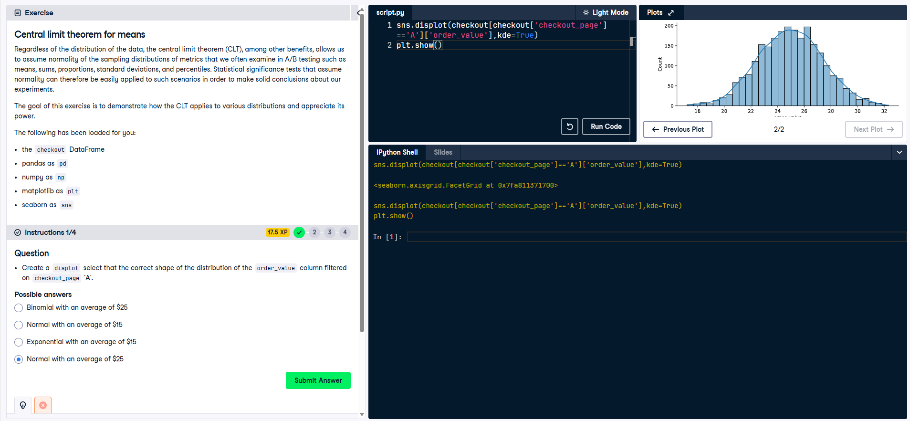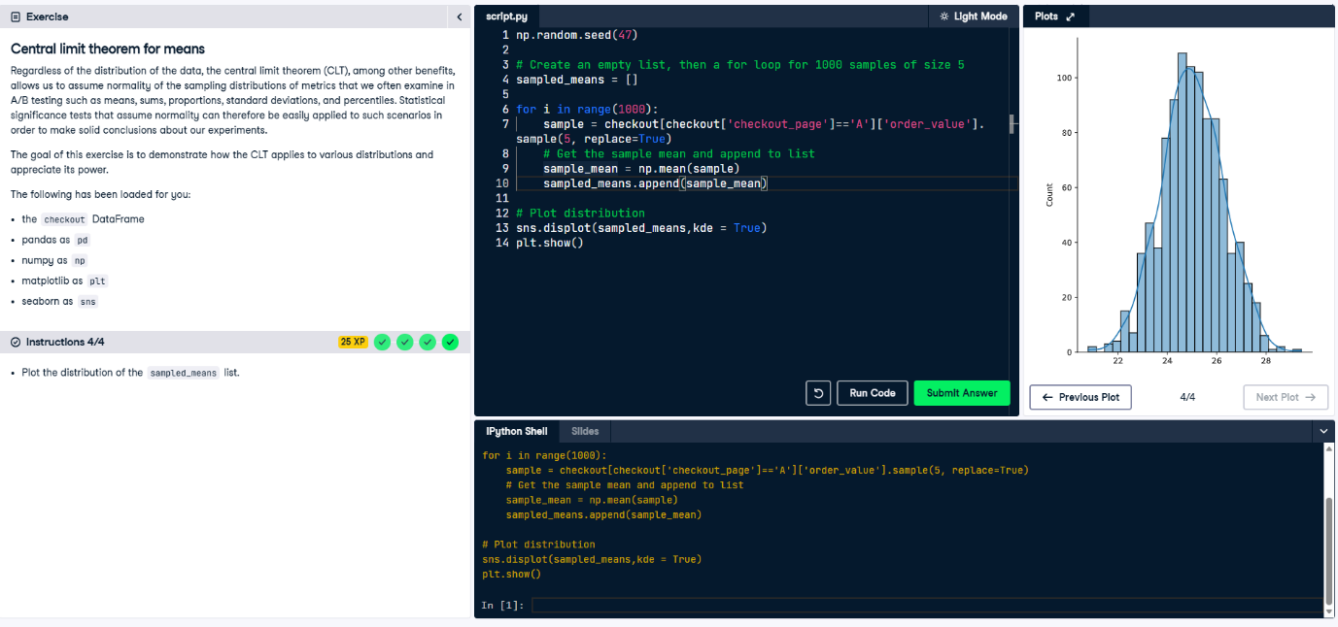

**Interpreting p-values**

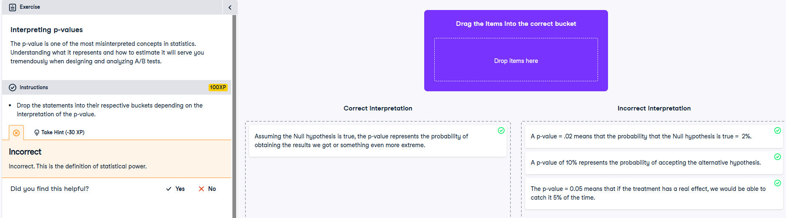

**Error rates in the wild**

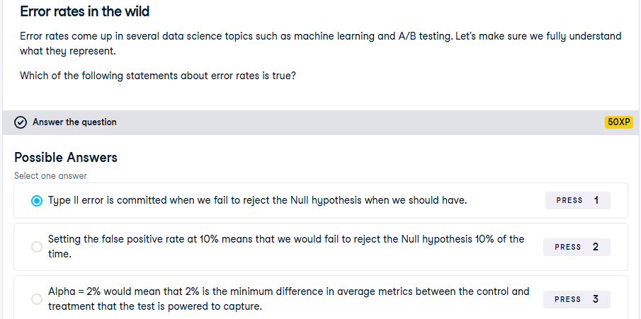

**Plotting power curves**

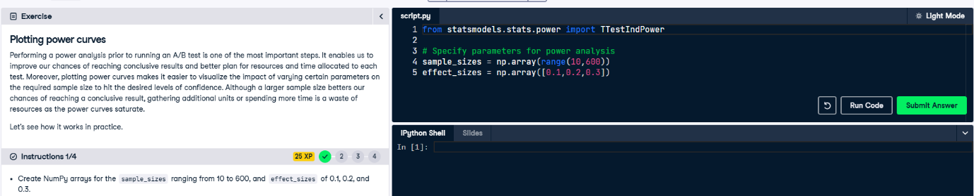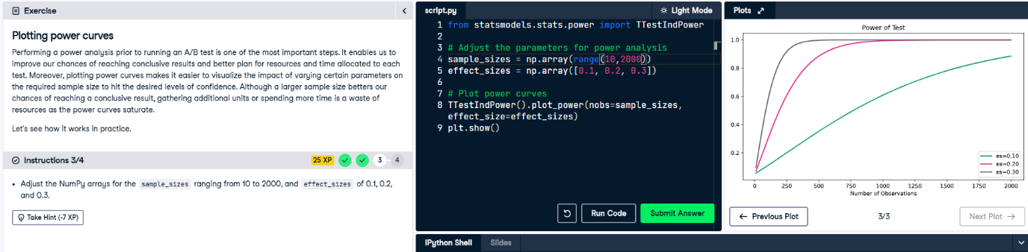

**Sample size for means**

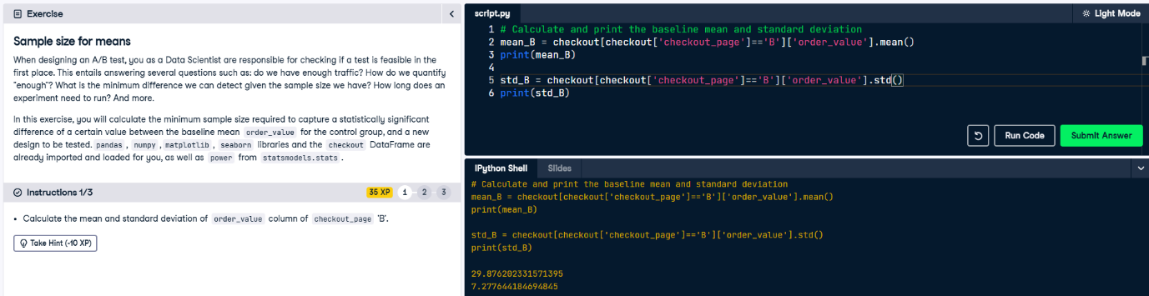

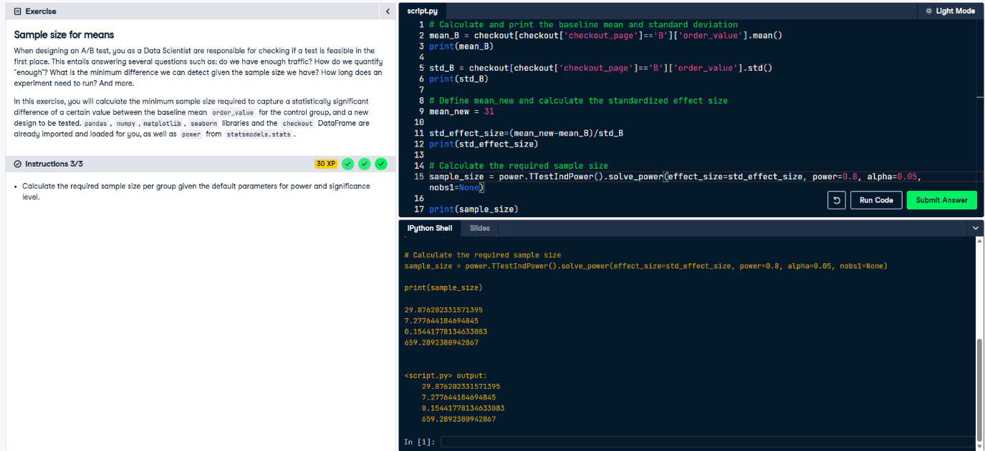

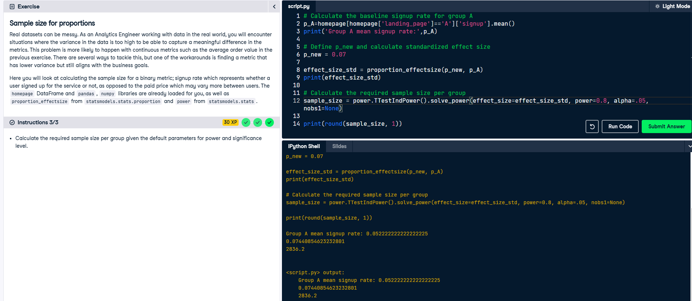

**Corrected p-values**

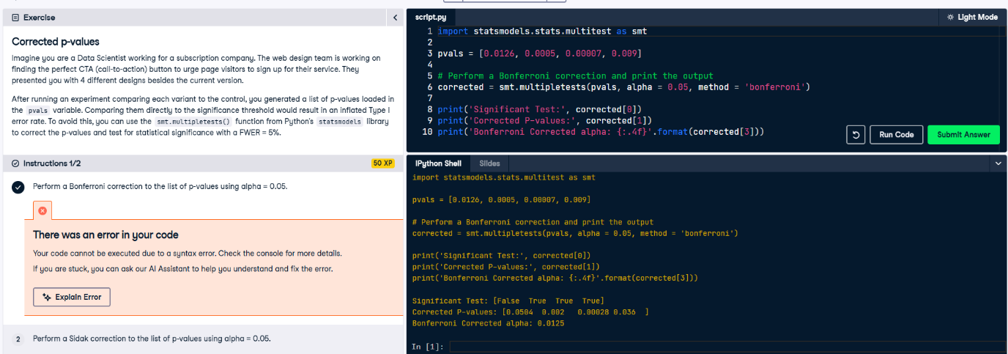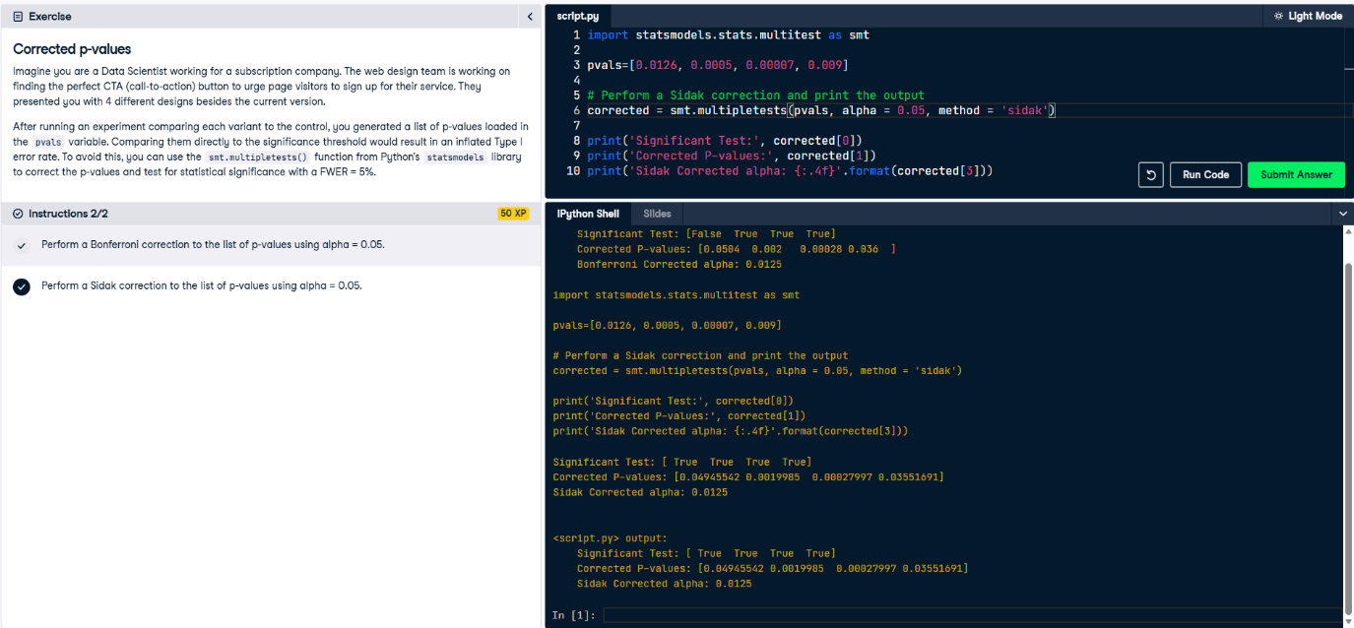

**For more information on A/B Testing:** https://ai.plainenglish.io/implementing-and-comparing-machine-learning-models-through-a-b-testing-a-python-guide-with-0f098381d91b